SIMATS ENGINEERING
ASSESSMENT TOOL 1

COURSE NAME: Database Management Systems COURSE CODE: CSA05

COURSE OUTCOME COVERED

CO2: Apply the relational model, relational algebra, SQL query structures, and views to solve database querying and data manipulation problems. (BL3, BL6)

Activity Tool : Analytical Problem Solving (High) Assessment Tool Weightage: 40%

QUESTIONS
Q.N o | Question | Bloom's Level
1 | Given a set of relations and sample data, write SQL queries to retrieve specific information using joins and subqueries, and explain the logic used.  Bloom’s Level: BL3 – Apply | BL4 – Analyze
2 | Using relational algebra, formulate expressions to solve complex queries such as retrieving records that satisfy multiple conditions across relations.  Bloom’s Level: BL4 – Analyse | BL5 – Evaluate
3 | Given a real-world scenario (e.g., banking or student system), design a relational schema and construct appropriate SQL queries for data retrieval and updates. Bloom’s Level: BL6 –  Create | BL6 – Create
4 | Analyse a given SQL query with nested subqueries and predict its output, explaining each step of execution. Bloom’s Level: BL4 – Analyze | BL6 – Create
5 | Compare different SQL approaches (joins vs subqueries) for solving the same problem and evaluate their efficiency. Bloom’s Level: BL5 – Evaluate | BL4 – Analyze
6 | Design and implement views for a database system to provide restricted data access, and justify their use for security and abstraction. Bloom’s Level: BL6 – Create | BL5 – Evaluate
7 | Given a database schema, write relational algebra expressions and convert them into equivalent SQL queries, analyzing differences in representation. Bloom’s Level: BL4 – Analyze | BL4 – Analyze
8 | Optimize a set of inefficient SQL queries by restructuring them using joins, indexing concepts, or views, and evaluate performance improvements. Bloom’s Level: BL5 – Evaluate | BL5 – Evaluate
9 | Develop a complex SQL query involving grouping, aggregation, and nested queries to solve a real-world problem. Bloom’s Level: BL6 – Create | BL6 – Create
10 | Given multiple relations, analyze the query requirements and decide whether to use views, joins, or subqueries, justifying your choice with reasoning. Bloom’s Level: BL5 – Evaluate | BL5 – Evaluate

Code of Conduct:

I Pragadish R(1925272030) (Name / Reg No) certify that this submission is my original work and that I have adhered to the guidelines specified for this assessment. I understand that any violation of academic integrity rules will result in disciplinary action.
Signature of the student: ADHAVAN CHANDRASEKAR(192521209)
RUBRICS FOR CALCULATION:

Criteria | Level 4 (Exemplary) | Level 3 (Proficient) | Level 2 (Developing) | Level 1  (Beginning  )
Problem  Understandin g | Clearly interprets problem,  identifies all  parameters and  requirements accurately | Understand s problem  with minor gaps | Partial understandin  g; misses key elements | Misinterpret s or unable to  understand problem
Method  Selection | Selects most appropriate  method/formul a with strong justification | Selects correct  method with minor errors | Inappropriate or partially correct method | Unable to select  method
Solution  Process | Logical, systematic steps with correct approach throughout | Mostly correct steps  with minor mistakes | Disorganized steps; multiple errors | No clear process
Accuracy of  Calculation | All calculations accurate; | Minor calculation errors | Frequent errors;  incorrect final answer | No valid calculations
 | correct final answer | 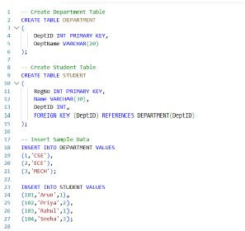
Interpretation of Results | Clearly interprets  results with units and  engineering relevance | Basic interpretatio n  with minor omissions | Limited or unclear interpretation | No  interpretatio n

ANSWERS:

1.Given a set of relations and sample data, write SQL queries to retrieve specific information using joins and subqueries, and explain the logic used.
Answer:
Create Student Table:
CREATE TABLE Student (
StudentID INT PRIMARY KEY,
StudentName VARCHAR(50),
Department VARCHAR(30)
);
Explanation:
The CREATE TABLE statement creates a table named Student. It contains three columns: StudentID, StudentName, and Department. The StudentID is the primary key, which uniquely identifies each student.
Insert Data into Student Table:
INSERT INTO Student VALUES
(101,'Arun','CSE'),
(102,'Bala','ECE'),
(103,'Divya','CSE'),
(104,'Kavin','IT');
Explanation:
The INSERT INTO statement adds four student records to the Student table
Student Table Output:
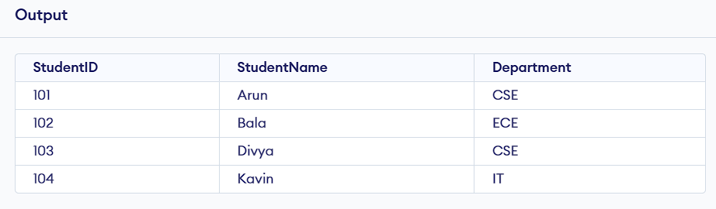
Create Course Table:
CREATE TABLE Course (
CourseID INT PRIMARY KEY,
CourseName VARCHAR(50),
StudentID INT,
Marks INT,
FOREIGN KEY (StudentID) REFERENCES Student(StudentID)
);
Explanation:
The Course table stores course details. The StudentID is a foreign key that links the Course table with the Student table.
Step 4: Insert Data into Course Table
INSERT INTO Course VALUES
(1,'Java',101,85),
(2,'Python',102,75),
(3,'SQL',103,92),
(4,'Java',104,68);
Explanation:
The INSERT INTO statement adds four course records to the Course table.
Course Table Output:
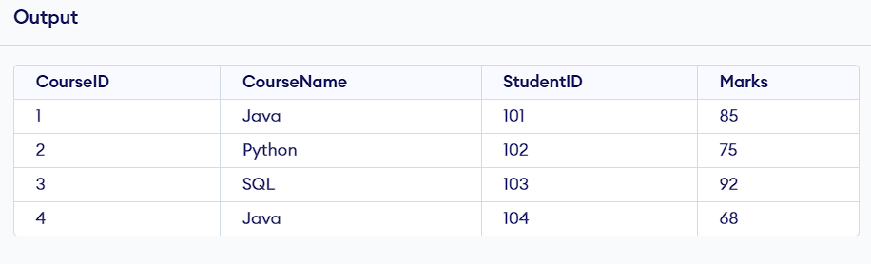

JOIN Query
SELECT Student.StudentName,
Student.Department,
Course.CourseName,
Course.Marks
FROM Student
INNER JOIN Course
ON Student.StudentID = Course.StudentID;
JOIN Output:
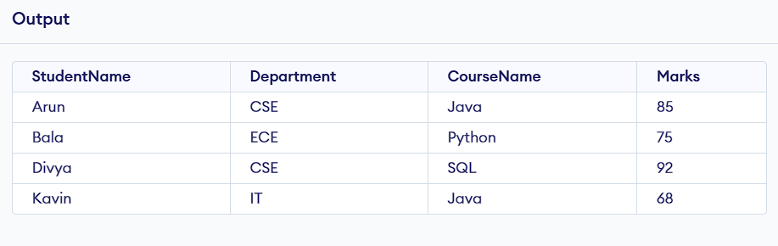
Explanation:
The INNER JOIN combines the Student and Course tables using the StudentID column. It returns only the records that have matching Student IDs in both tables.
Subquery:
SELECT StudentName
FROM Student
WHERE StudentID IN
(
SELECT StudentID
FROM Course
WHERE Marks > 80
);

Subquery Output:
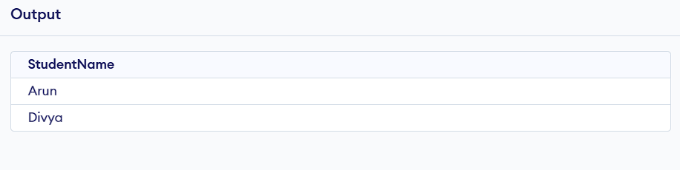
Explanation:
The subquery first finds the StudentID values of students who scored more than 80 marks. The outer query then retrieves the names of those students from the Student table.
Conclusion:
This SQL program demonstrates the use of JOIN and Subquery. The INNER JOIN combines related data from two tables using a common column, while the Subquery retrieves data based on the result of another query. These SQL techniques help in efficiently retrieving and analyzing data from relational databases.

2. Using relational algebra, formulate expressions to solve complex queries such as retrieving records that satisfy multiple conditions across relations.
Answer:
Student Relation:
StudentID | StudentName | Department
101 | Arun | CSE
102 | Bala | ECE
103 | Divya | CSE
104 | Kavin | IT

Course Relation:
CourseID | CourseName | StudentID | Marks
1 | Java | 101 | 85
2 | Python | 102 | 75
3 | SQL | 103 | 92
4 | Java | 104 | 68

Problem Statement:
Retrieve the names of students who belong to the CSE department and scored more than 80 marks.
Relational Algebra Expression:
π StudentName (
σ Department='CSE' AND Marks>80 (
Student ⨝ Student.StudentID = Course.StudentID Course
) )
Explanation:
- Join (⨝): Combines the Student and Course relations using the common attribute StudentID.
- Selection (σ): Selects only the records where Department = 'CSE' and Marks > 80.
- Projection (π): Displays only the StudentName attribute.

Output:
StudentName
Arun
Divya

Conclusion:
The relational algebra expression retrieves students who satisfy multiple conditions across two relations. It uses Join to combine the relations, Selection to filter the required records, and Projection to display only the required attribute.

3. Given a real-world scenario (e.g., banking or student system), design a relational schema and construct appropriate SQL queries for data retrieval and updates.
Answer:
Scenario
Student Management System:
The Student Management System stores student information, course details, and marks. It helps to retrieve student information and update student records.
Relational Schema:
Student(StudentID, StudentName, Department)
Course(CourseID, CourseName, StudentID, Marks)
Create Student Table:
CREATE TABLE Student (
StudentID INT PRIMARY KEY,
StudentName VARCHAR(50),
Department VARCHAR(30)
);
Explanation:
This table stores the details of students. StudentID is the primary key.
Create Course Table:
CREATE TABLE Course (
CourseID INT PRIMARY KEY,
CourseName VARCHAR(50),
StudentID INT,
Marks INT,
FOREIGN KEY (StudentID) REFERENCES Student(StudentID)
);
Explanation:
This table stores course details and student marks. StudentID is a foreign key that links to the Student table.
Insert Sample Data:
Student:
INSERT INTO Student VALUES
(101,'Arun','CSE'),
(102,'Bala','ECE'),
(103,'Divya','CSE'),
(104,'Kavin','IT');
Course:
INSERT INTO Course VALUES
(1,'Java',101,85),
(2,'Python',102,75),
(3,'SQL',103,92),
(4,'Java',104,68);

Student Table Output:

Course Table Output:
CourseID | CourseName | StudentID | Marks
1 | Java | 101 | 85
2 | Python | 102 | 75
3 | SQL | 103 | 92
4 | Java | 104 | 68

Data Retrieval Query:
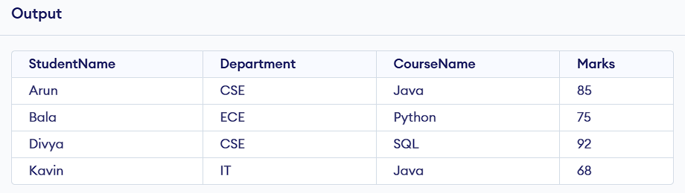
Explanation:
The query retrieves student details along with their course and marks by joining the Student and Course tables.
Data Update Query:
UPDATE Course
SET Marks = 90
WHERE StudentID = 101;
Explanation:
This query updates Arun's marks from 85 to 90.
Updated Output:
SELECT * FROM Course;
Output:
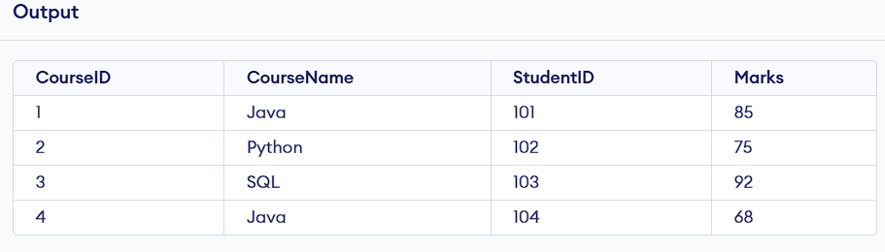
Conclusion:
The Student Management System demonstrates how to design a relational database schema, create tables, insert data, retrieve information using SQL queries, and update records using the UPDATE statement.

4. Analyse a given SQL query with nested subqueries and predict its output, explaining each step of execution.
Answer:
Consider the Tables:
Student


Course

SQL Query with Nested Subquery:
SELECT StudentName
FROM Student
WHERE StudentID IN
(
SELECT StudentID
FROM Course
WHERE Marks =
(
SELECT MAX(Marks)
FROM Course
)
);
Step-by-Step Execution
Step 1 (Innermost Subquery):
SELECT MAX(Marks)
FROM Course;

Explanation:
The innermost subquery finds the highest marks in the Course table, which is 92.

Output:
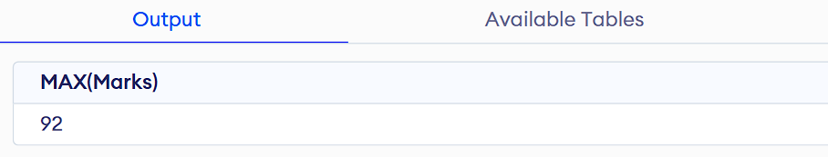
Step 2 (Second Subquery):
SELECT StudentID
FROM Course
WHERE Marks = 92;
Output:
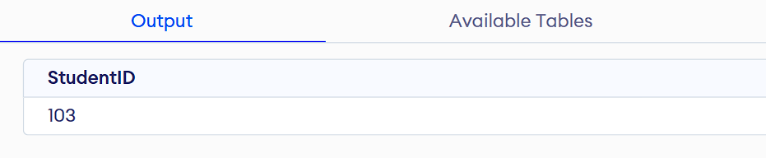
Explanation:
This subquery finds the StudentID of the student who scored the highest marks.
Step 3 (Outer Query):
SELECT StudentName
FROM Student
WHERE StudentID IN (103);
Output:
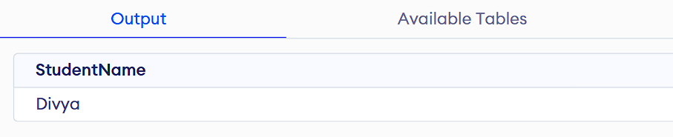
Explanation:
The outer query uses StudentID = 103 to retrieve the student's name from the Student table.
Final Output:

Conclusion:
The nested subquery executes from the inside out:
- The innermost query finds the maximum marks.
- The middle query finds the StudentID with those marks.
- The outer query retrieves the corresponding student name.
Thus, the final result is Divya, who scored the highest marks (92).

5. Compare different SQL approaches (joins vs subqueries) for solving the same problem and evaluate their efficiency.
Answer:
Consider the Tables:
Student


Course

Problem Statement:
Retrieve the names of students along with their course names.
Solution Using JOIN:
SQL Query
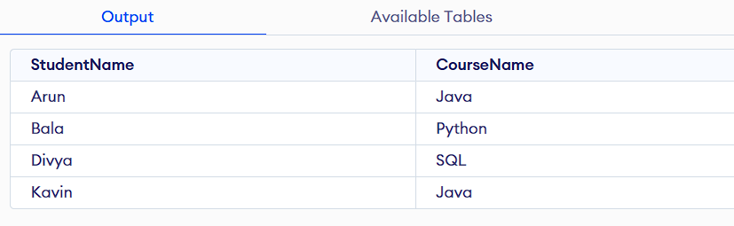
Explanation:
The INNER JOIN combines the Student and Course tables using the common column StudentID and retrieves matching records.
Solution Using Subquery:
SQL Query


Explanation:
The subquery retrieves the course name for each student by matching the StudentID.
Comparison:
Feature | JOIN | Subquery
Performance | Faster | Slower
Readability | Easy for multiple tables | Easy for simple queries
Execution Speed | High | Moderate
Best Use | Combining multiple tables | Filtering or single-value retrieval

Evaluation:
- JOIN is more efficient because it retrieves data from multiple tables in a single query.
- Subquery may execute repeatedly for each row, making it slower for large datasets.
- For retrieving related data from multiple tables, JOIN is generally the better choice.
Conclusion:
Both JOIN and Subquery can solve the same problem and produce the same output. However, JOIN is generally more efficient, faster, and preferred for combining data from multiple tables, while Subqueries are useful for simpler filtering operations or when a query depends on the result of another query.

6.Design and Implement Views for a Database System to Provide Restricted Data Access, and Justify Their Use for Security and Abstraction
Answer:
Scenario: Student Management System
Create Database:
CREATE DATABASE StudentDB;
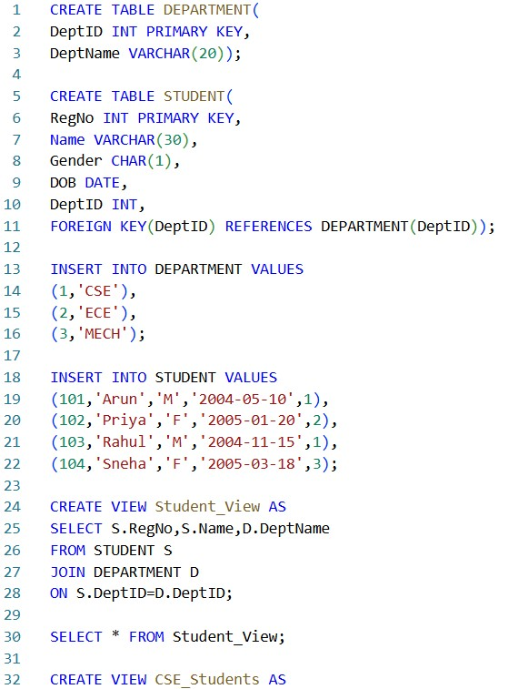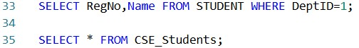

Output:
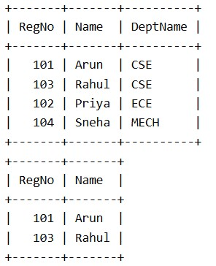
7. Given a database schema, write relational algebra expressions and convert them into equivalent SQL queries, analyzing differences in representation.
Answer:
STUDENT(RegNo, Name, Gender, DOB, DeptID)
DEPARTMENT(DeptID, DeptName)

-- Relational Algebra Expressions

- Display Student Name and Department Name π Name, DeptName
(STUDENT  STUDENT.DeptID = DEPARTMENT.DeptID DEPARTMENT)

- Display Students Belonging to the CSE Department π Name
(σ DeptName='CSE'
(STUDENT  STUDENT.DeptID=DEPARTMENT.DeptID DEPARTMENT))

- Display Registration Number and Name of Students with DeptID = 1 π RegNo, Name (σ DeptID=1(STUDENT))

8.Optimize a set of inefficient SQL queries by restructuring them using joins, indexing concepts, or views, and evaluate performance improvements.
Answer:
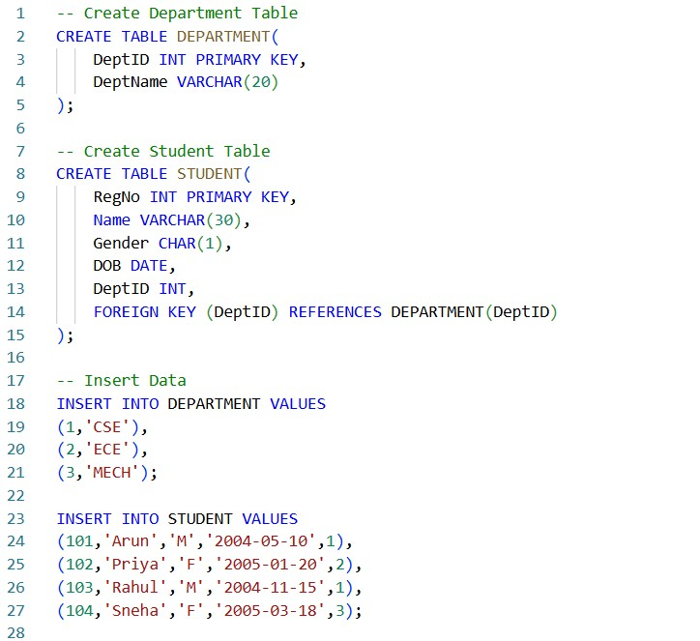

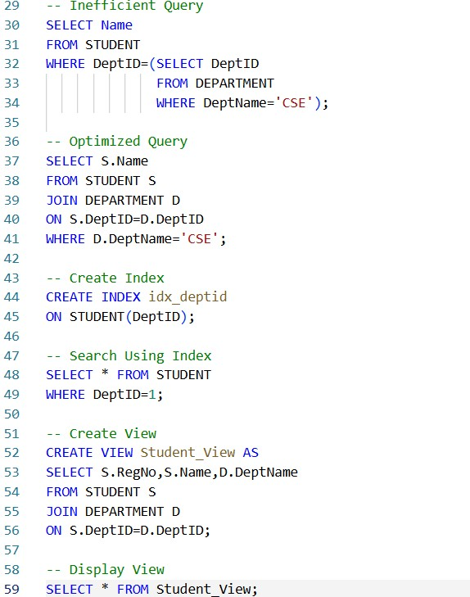

Output:
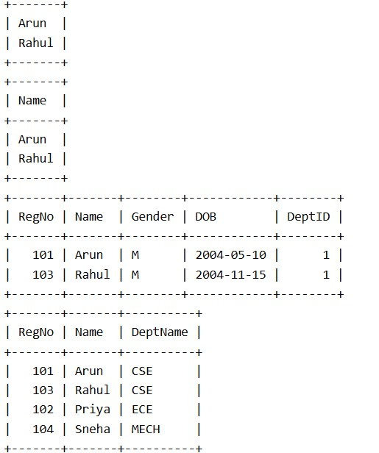

9. Develop a complex SQL query involving grouping, aggregation, and nested queries to solve a real-world problem.
Answer:
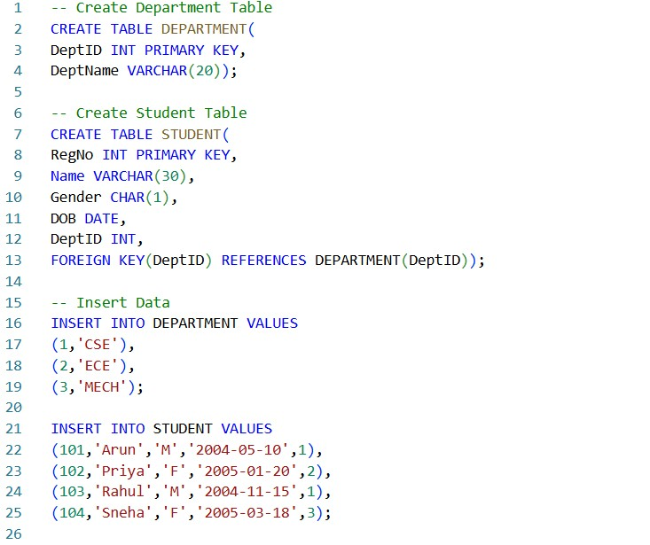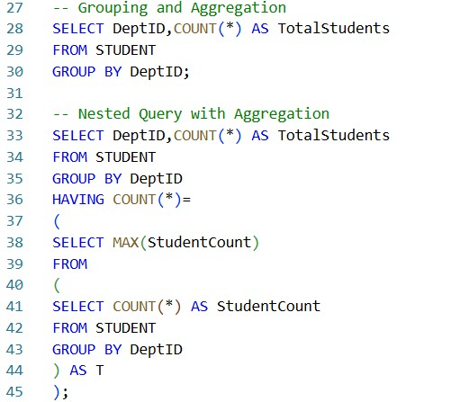

Output:
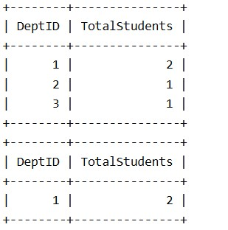

10. Given multiple relations, analyze the query requirements and decide whether to use views, joins, or subqueries, justifying your choice with reasoning.
Answer:
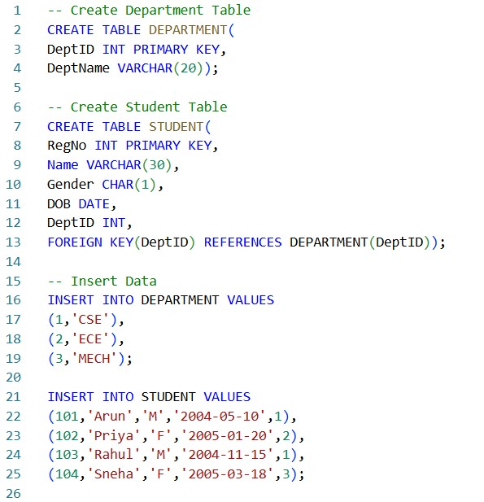
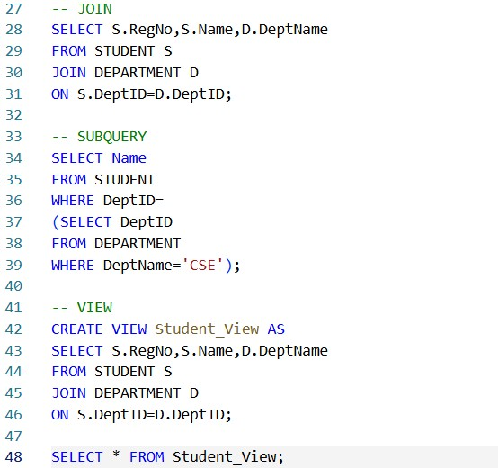

Output:
